

SIMATS SCHOOL OF ENGINEERING
SAVEETHA INSTITUTE OF MEDICAL AND TECHNICAL SCIENCES
CHENNAI-602105

M.NAGA SHALINI(192524183)

ASSESSMENT 2
CSA1006-SOFTWARE ENGINEERING
Problem 1: Requirements Elicitation & Prioritization in a College Attendance System
Scenario
A college plans to develop an Attendance Management System. Different stakeholders have different requirements. Students want to check their attendance using a mobile application. Teachers prefer biometric attendance to avoid proxy attendance. College management wants the system to be low-cost and completed within a short development time. Since these requirements conflict with each other, proper requirement elicitation, prioritization, and conflict resolution are necessary.

Objective
The objective is to identify the system requirements, prioritize them using the MoSCoW method, classify them using the Kano Model, and resolve stakeholder conflicts while maintaining cost and development efficiency.

1. Functional Requirements
The following are the major requirements of the College Attendance Management System.

Requirement 1
Students should be able to view their attendance percentage through a mobile application.

Requirement 2
Teachers should be able to mark attendance using biometric authentication to prevent proxy attendance.

Requirement 3
The management should be able to generate attendance reports for every department and class.

Requirement 4
The system should be developed with a low-cost solution and should be completed within the given deadline.

2. MoSCoW Prioritization
Requirement | Priority | Reason
Student atendance checking through mobile app | Must Have | Core functionality required by students
Teacher biometric attendance | Should Have | Improves security but can be added later
Attendance reports for management | Could Have | Helpful for administration but not essential in the first release
Additional notifications and advanced analytics | Won't Have | Can be implemented in future versions

3. Kano Model Classification

Basic Requirement
Secure login is a basic requirement because every user expects the system to provide secure access.

Performance Requirement
Attendance checking is a performance requirement because users expect fast and accurate attendance information.

Excitement Requirement
Attendance graphs, statistics, and notifications are excitement features because they improve user satisfaction but are not mandatory.

4. Stakeholder Conflict
Students prefer a simple mobile application that allows them to check attendance from anywhere.
Teachers prefer biometric attendance because it reduces fake attendance and increases accuracy.
Management wants the project to be completed quickly while keeping the development cost as low as possible.

5. Conflict Resolution Plan
The conflict can be resolved by following a phased development approach.
In the first phase, the system will provide student login, attendance viewing, teacher attendance management, and report generation.
In the second phase, biometric authentication will be integrated after the initial system is successfully deployed and additional budget is available.
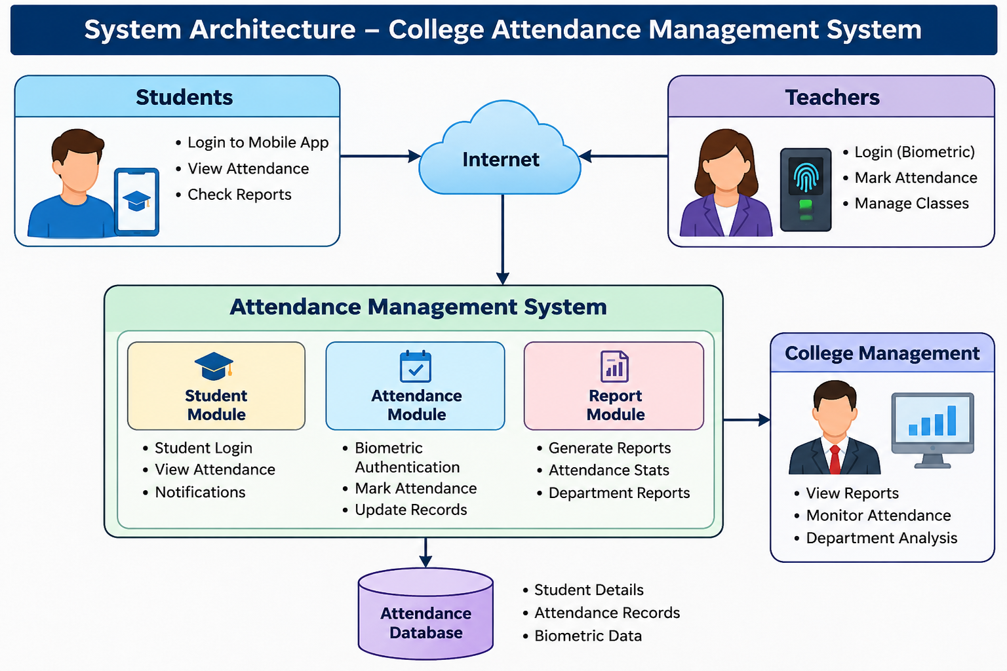

Reasoning
Requirement elicitation helps gather the needs of all stakeholders before development begins.
MoSCoW prioritization ensures that the most important features are developed first.
The Kano Model helps understand which features are essential and which features improve user satisfaction.
Conflict resolution balances the expectations of students, teachers, and management while considering project cost and delivery time.

Conclusion
The College Attendance Management System is a good example of applying Requirements Engineering principles. By identifying stakeholder requirements, prioritizing features using the MoSCoW technique, classifying features with the Kano Model, and resolving conflicts through phased implementation, the project can be developed successfully. This approach ensures better software quality, lower cost, timely delivery, and improved user satisfaction.

References
- Ian Sommerville, Software Engineering, 10th Edition.
- Roger S. Pressman, Software Engineering: A Practitioner's Approach.
- IEEE Software Requirements Specification (SRS) Guidelines.
- Agile Requirements Engineering Practices.

